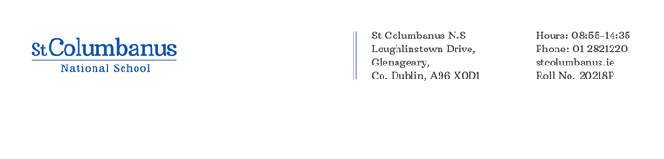
Principal: Mrs. Carmel Murphy
Deputy Principal: Mr. Seán Walshe
Dear Parents/Guardians,

As you know classes reverted to remote learning on Monday 11th of January. This is so disappointing for us all and not what we were hoping for at the start of a new year. However, we are hopeful that with the roll out of the vaccine we will in time return to more normal day to day living. For information on remote learning see our school website.
We are aware of the difficulties faced by our families during this pandemic and we know that on-line education is a challenge. We wanted to remind you that we have no expectation that during this time you become your child’s substitute teacher. We also do not expect you to be doing hours of tutoring with your child every day. We encourage you to be realistic about your child’s needs and your own needs.

When trying to think about how we can support ourselves, our families, our communities and our country in the coming weeks, it can be helpful to remind ourselves of these three key messages:

- Stay Responsible & Informed
- Stay Active & Connected
- Stay Positive & Calm

On the following page, we have created links to a range of resources which you may find helpful. Please feel free to contact us on stcolum@gmail.com if you have any concerns.

Stay Safe.
Kind regards,

Carmel Murphy
Principal

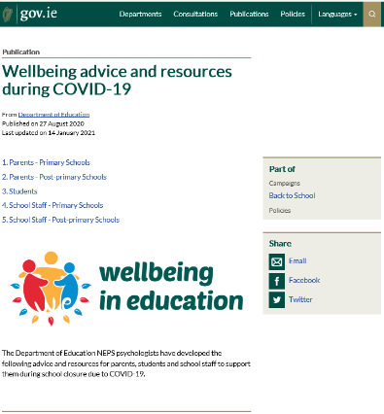

The Department of Education National Educational Psychology Service (NEPS) have many resources that you may find useful while the school is closed. These resources can be found on the Department website here

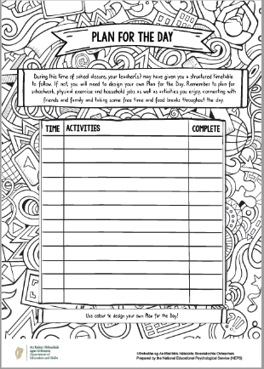
Plan for a Day
A plan for the day template is available here to help you and your child put a structure on the day. It suggests trying to have a schedule, creating time for fun activities, time for learning, break times and time for physical activity.

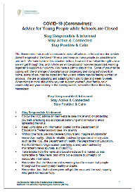
Advice for Young People
NEPS has published Advice for Young People while Schools are Closed which is available here

Relaxation Techniques Podcast
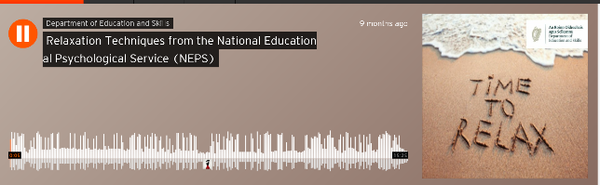
This link will take you to a podcast from NEPS to help parents and pupils practise relaxation techniques.

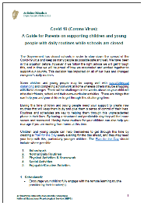
Advice for Parents
NEPS has also published A Guide for Parents on Supporting Children and Young People with Daily Routines while Schools are Closed which is available here

