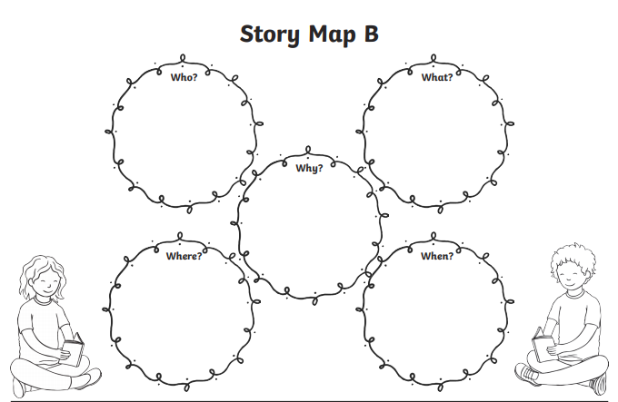
Write, talk and draw about the story using these question words. Who is it about? What happens in the story? Where did the characters go? Why did they go there? When did the story take place?
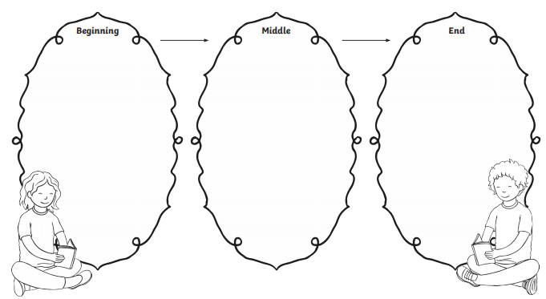

Write, talk and draw about what happened in the beginning, middle and end of the story!

